**Data-driven Sales and Demand Prediction for Electrical Appliance Supplier**

**A Proposal report for the BDM Capstone Project**

Submitted by

Trivedhan Sivaprakash

21F1001724



IITM Online BS Degree Program,

Indian Institute of Technology, Madras, Chennai

Tamil Nadu, India, 600036

**Contents**

Executive Summary……………………………………………………………………………2

Organization Background……………………………………………………………………...2

Problem Statement……………………………………………………………………………..3

Background of the problem…………………………………………………………………….3

Problem solving approach……………………………………………………………………..3

Expected Timeline……………………………………………………………………………..5

Expected Outcome……………………………………………………………………………..5

**Data-driven Sales and Demand Prediction for Electrical Appliance Supplier**

**Executive Summary**

The objective of the project is to develop an accurate and reliable forecast model to predict the sales and demand of an Electrical appliance supply company.

The Business is a supplier that focuses on wholesale purchase and bulk selling of Electric Appliances such as Water heaters, Stabilizers, Grinders, Fans etc. from well-known brands such as Vguard, Crompton,etc. to various dealers across the district. The business encountered a period of severe low revenue following the advent of COVID-19. This according to the owner, could majorly be attributed to unpreparedness and poor inventory management. This project aims to provide a solution to this. By taking into consideration various external and internal factors such as past sales, seasonality, customer churn, inflation, etc, a robust predictive model to forecast variations in sales and demand is to be built.

The data obtained would be cleaned and formatted for analysis. Using the cleaned data, a predictive ARIMA model for sales and demand can be developed using python modules and various other tools such as Excel, Scipy, Sklearn, Linear regression and Pareto analysis,etc. Tests like pareto analysis will be performed to identify trends. The outcome of this will be to predict the sales and demand and thereby help maximize the profitability of the business.

# Organization Background

The name of the company is Om Muruga Services and they are suppliers who purchase and sell electrical appliances like Water Heaters, Stabilizers, Fans, Mixers and Grinders from leading manufacturers like V-Guard, Havell’s,etc. It was established in the year 2010 and is based in the Vellore district of Tamil Nadu. The size of the company is roughly 50-100 employees. Their yearly estimated turnover is approximately Rs.60,00,000. They have been supplying to over 300+ electronics dealers across Vellore and its neighboring districts. In addition to this, they also have authorized mechanics who provide services for Product Installation, repair and maintenance of their products free of cost to customers. Customer satisfaction and commitment forms the core of their work ethics.

**Problem Statement**

1. Problem statement 1: Lack of a reliable systematic method to predict sales behavior in order to facilitate better management of business operations
2. Problem statement 2: Lack of a reliable systematic method to predict variations in demand in order to facilitate better management of inventory

# Background of the Problem

The business dealer faces several challenges that need to be addressed through data analysis and management. They informed that it was largely due to unpreparedness and mismanagement to face the pandemic, that they faced a major fall back in terms of revenue for the past 2 years. Here are some of their key problem areas:

* Poor knowledge of internal and external factors affected the business: Without accurate knowledge on market insights, seasonal variations in sales, customer churn, inflation rates, etc, the business struggled. Lack of market intelligence can hinder product development, marketing strategies, and decision-making processes.
* Ineffective Sales Forecasting: Accurate sales forecasting is critical for inventory planning, production scheduling, and resource allocation. Inaccurate forecasts can lead to stockouts or excess inventory, resulting in lost sales or increased costs.
* Sales Performance Variability: The business may experience fluctuations in sales performance, making it challenging to predict and plan for business operations. This variability can be influenced by factors such as seasonality, market trends, customer preferences, and competition.
* Inventory Management Issues: Inaccurate inventory forecasting and management can lead to stockouts, excess inventory, or obsolete products. Optimizing inventory levels is crucial to ensure availability of popular products while minimizing holding costs.

# Problem Solving Approach

* + - 1. Using Microsoft Excel to clean the sales and purchase data of the business: In this step, the sales and purchase data obtained will be imported into Excel, and data cleaning techniques such as removing duplicates, handling missing values, and correcting data inconsistencies will be implemented.
      2. A comprehensive study of internal and external factors affecting the sales and demand would be thoroughly carried out: This step involves conducting a detailed analysis of various factors that can influence sales and demand. Internal factors such as historical sales data, product performance, customer behavior, pricing strategies, and promotions will be examined. External factors like seasonality, economic indicators and market trends will also be considered. By studying these factors, their impact on sales and demand can be understood, and appropriate adjustments can be made in the forecasting model.
      3. Visualize the data, identify and analyze trends in data by plotting various kinds of graphs using MS excel: Calculations, aggregations, and statistical analysis would be performed on the data which will then be visualized using charts, graphs, and pivot tables to identify trends, patterns, and correlations within the data. These visualizations help in identifying key insights, anomalies, and patterns in the data, facilitating a better understanding of the sales and demand dynamics.
      4. Obtaining more accurate and reliable forecast using machine learning algorithms using tools like Scipy, Sklearn and other python modules: Machine learning algorithms can be implemented using Python libraries such as Scipy and Sklearn to build predictive models based on historical sales and demand data. Techniques like linear regression, decision trees, random forests, and gradient boosting can be employed to train the models. The models can then be used to predict future sales and demand based on the learned patterns and relationships, providing a more reliable forecast for the business.
      5. Based on the insights provided by the forecast model, various strategies would be devised to help maximize profitability by ensuring preparedness and optimum inventory storage.

# Expected Timeline

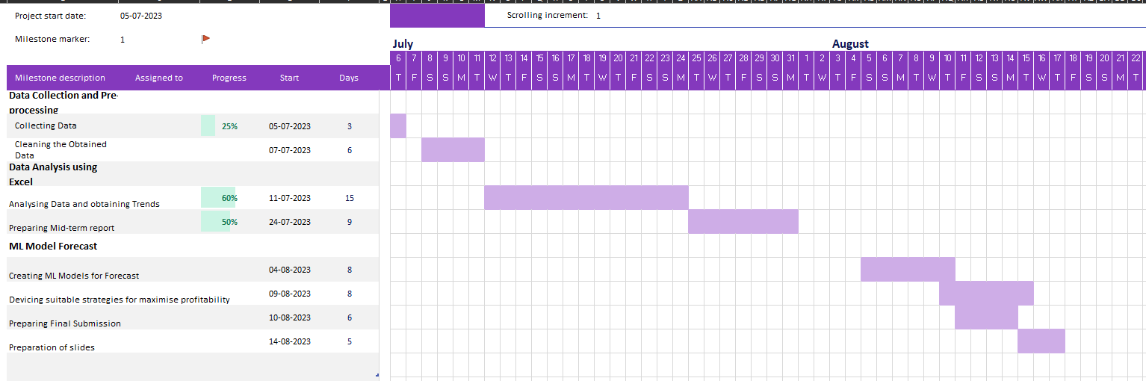

**Expected Outcomes**

Through the thorough study of internal and external factors, the business will gain insights into the drivers of sales and demand fluctuations, enabling them to make informed decisions and adjustments in their strategies to meet the market variations.

The analysis of sales trends, seasonal patterns, and correlations between variables will help identify growth opportunities, patterns in customer behavior, and potential areas for improvement.

The predictive model will generate accurate forecasts based on historical data and learned patterns, enabling the company to make proactive decisions, optimize inventory management, and improve overall operational efficiency.

With accurate sales and demand forecasts, the business can optimize its inventory storage, prevent stockouts or excess inventory, and align production and procurement strategies accordingly. This will result in cost savings, reduced inventory holding costs, and improved profitability.